Tweeter

(Initial Proposal)

We are going to be building a twitter like app with a live text feed. Users will be able to login and register into proprietary accounts to interact with other peoples posts.

**UI Mockup**

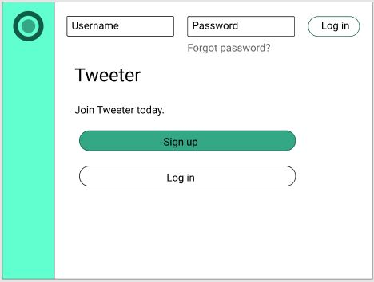

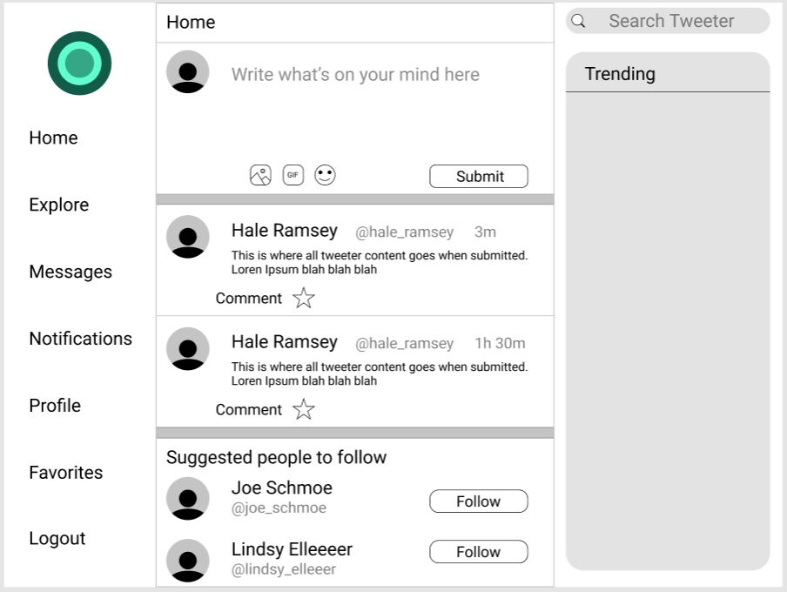

Priority:

Need

* Login/Registration
* Main Feed
* Profile
* Comments

Want

* Images
* DM’s
* Retweet
* Likes

Would like

* Gifs
* Videos

**Checkpoint 1** - 11/23

Tasks: - UI mockup

* Uml backend architecture

- set up servers

- splash page

- set up mongoDB

**Checkpoint 2** - 11/30

Tasks: - login and registration in React

- main feed

- profiles

**Checkpoint 3** - 12/07

Tasks: -

**Checkpoint 4** - 12/11

Tasks: - Working version of application